The process of narrowing down a topic
Narrowing down means deciding what should go into the paper and what should be left out. It is useful to begin by exploring various aspects of the topic that the research work is to focus on. This means to initially start by approaching the topic quite broadly, so that interesting and important aspects can be found and evaluated.
- An initial thought on the topic of the term paper could look like this:
" I am writing something about motivation in learning processes".
Now it is important to find out which related topics could be linked to this first idea. The literature and discourse of the seminar as well as further research can be useful for this purpose. A "mind map" or "concept map" shows possible connections and visualises the range of the idea at one glance:
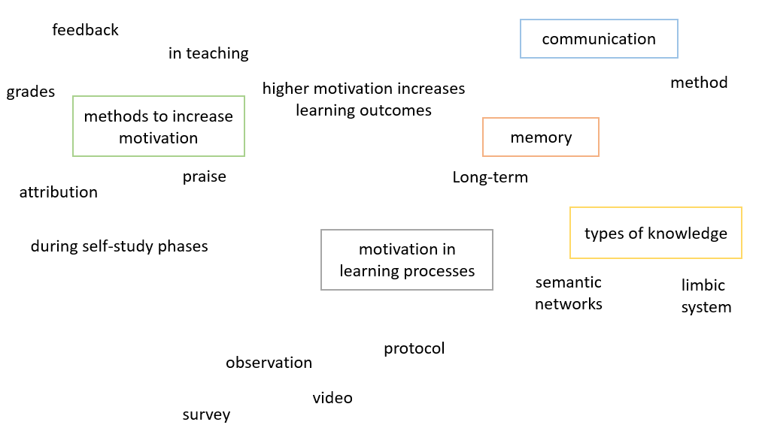
- This incomplete overview shows first aspects, theses and subject areas which may be useful for further research. Thereupon, keyword searches can be carried out via Google Scholar, in OPAC, HEBIS, Worldcat or even by simply using Google:
- Motivation in lessons
- Increase motivation at school
- Learning and motivation
- Long term learning performance Motivation
- Measuring motivation
- Attribution
- etc.

- With this new understanding in mind, the first idea can now be concretized. It may be useful for a seminar paper, for example, to select only one specific aspect. Possible topics could be:
- Attribution procedures in securing phases
- Motivation through incentives in primary education
- Maintaining motivation with the LDL method
- Giving motivating feedback

- The decision on what type of approach the work should take requires clarification:
Do I want to describe? > descriptive
Do I want to do research? > analytical, experimental
Do I want to find? > exploring (= exploratory)
Would I like to proof? > verifying hypotheses (= confirmatory)
Would I like to interpret? > interpretative/discursive

- Although different parts of the paper will touch on some of these focal points - the introduction will be more explorative and descriptive, the main part more analytical/experimental, the conclusion more interpretative/discursive - the global approach also determines the overall character of the paper, i.e. what it aims to achieve or wants to show.
These decisions contribute to a better understanding of the topic and to define the orientation of the topic more concretely. The process of narrowing down the topic is therefore not only focused on the content, but also on the methodology and already aims at a possible goal or result.

Headstand method
An associative, somewhat rougher method of narrowing down topics is to create a pool, e.g. via brainstorming, followed by categorisation into suitable and unsuitable topics. In the categorisation step, the volume and effort required for the research work is also taken into account.
For example:
Idea: Motivation in learning processes
Increase long-term learning performance
Motivation through incentives
Maintaining motivation through incentives
Motivation in lower secondary school students
Motivating social forms in the classroom
Long-term learning effects through negative reinforcement
Learning is stupid
Motivation through gamification
Motivation increases long-term learning success

Suitable topics | Unsuitable topis
Motivation through gamification | Learning is stupid
Motivation increases long-term learning success | Motivation through incentives
Maintaining motivation through incentives | Long-term learning effects through negative reinforcement
Motivation in lower secondary school students
Motivating social forms in the classroom

Abstract
In order to formulate a topic as specifically as possible and to make it tangible for oneself, the drafting of an abstract can be helpful as an exercise. The abstract is a text of approx. 300 to 500 words, which can be a good preparation for consultation meetings. The aim of the abstract is to provide the addressees with the means to make a decision about the thematic relevance of the work within minutes. As a rule, the abstract includes information on (1) the object of the study, on (2) the method, on (3) the (expected) results and on (4) the (possible) interpretation of the results. This allows supervisors and examiners to decide more quickly on the suitability of the topic and give concrete feedback (on individual aspects of the research project) in consultation meetings.

Formulating work assignments
Being able to define a topic yourself is an important skill that needs to be practiced and reflected upon. The more precisely the topic is specified, the more precisely the work assignments can be formulated for the inner writer. These could look something like this:
- Find out what exactly motivation means.
- Show how the use of motivational methods in the classroom has developed.
- Lead the reader to the research question.
- Discuss why method X can only be used in the following context.

The precise acquisition of research and reading goals on the basis of work assignments contributes to the efficient examination of a topic. It also helps strengthen the own academic position by reading based on the own research question and not losing orientation by falling into the argumentation logic of research literature.
Further assistance for the reading process can be found in the handout Reading Strategies on the Writing Center’s Website.

cf. Kruse, Otto. Keine Angst vor dem leeren Blatt. Ohne Schreibblockaden durchs Studium. Frankfurt (Main), Campus, 1993, p. 224f.
Further comprehensive information about writing an abstract: Huemer, Birgit/Rheindorf, Markus/Gruber, Helmut. Abstracts, Exposé und Förderantrag. Vienna, Cologne, Weimar, UTB Böhlau, 2012.

